**How to Access the Hub**

You can get to the Hub two ways:

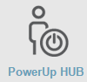Long way but foolproof ☺

1. Go to [www.houstonisd.org](http://www.houstonisd.org)
2. Scroll down till you see the Powerup Hub icon and click it.
3. Click on the box that says “Login using Houston ISD account”

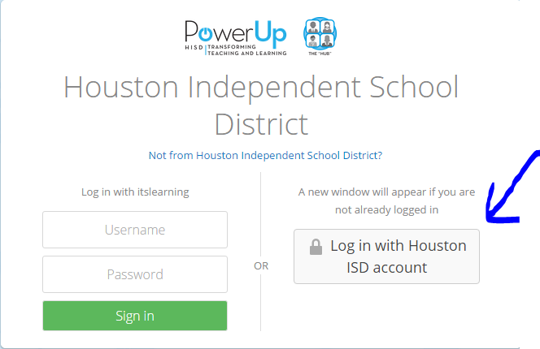

1. Enter your login information:

**Username: student ID preceded by the letter “S” (e.g.: S123456)**

**Password: birthdate as 8 digits in mmddyyyy format (e.g: 01012007)**

Short way

1. Go to [https:\\houston.itslearning.com](https://houston.itslearning.com)
2. Click on the box that says “Login using Houston ISD account”



1. Enter your login information:

**Username: student ID preceded by the letter “S” (e.g.: S123456)**

**Password: birthdate as 8 digits in mmddyyyy format (e.g: 01012007)**